TAB Application setting

2.Initial Settings UI 3
2.1 DB Server Settings 3
2.2 Printer Settings 5
2.3 UI Settings 9
After completing server and printer settings there is option for adjusting the ui settings.When clicked on the App , a new window will open as shown below. 9
3.Waiter List 11
4.Login 12
5.Table List UI. 13
5.1 Location Selection. 13
5.2 Table List 14
5.3)Seat and Pax Selection 16
6.Order List UI. 18
6.1 Order List. 18
6.2 Order Menu Options. 19
7. Item List UI. 21
7.1 Item List. 21
7.2 Menu Selection. 24
7.3 Item Class Selection. 25
8.Cart UI. 27
8.1 Cart Item List. 27
8.2 Item Edit. 29
8.3 Parking and Printing. 31

2.Initial Settings UI

2.1 DB Server Settings
Double click on the eezDine app icon ,a new window will open as shown below.If it is the first time you are using the system ,some configurations should be done to connect to the server or database.

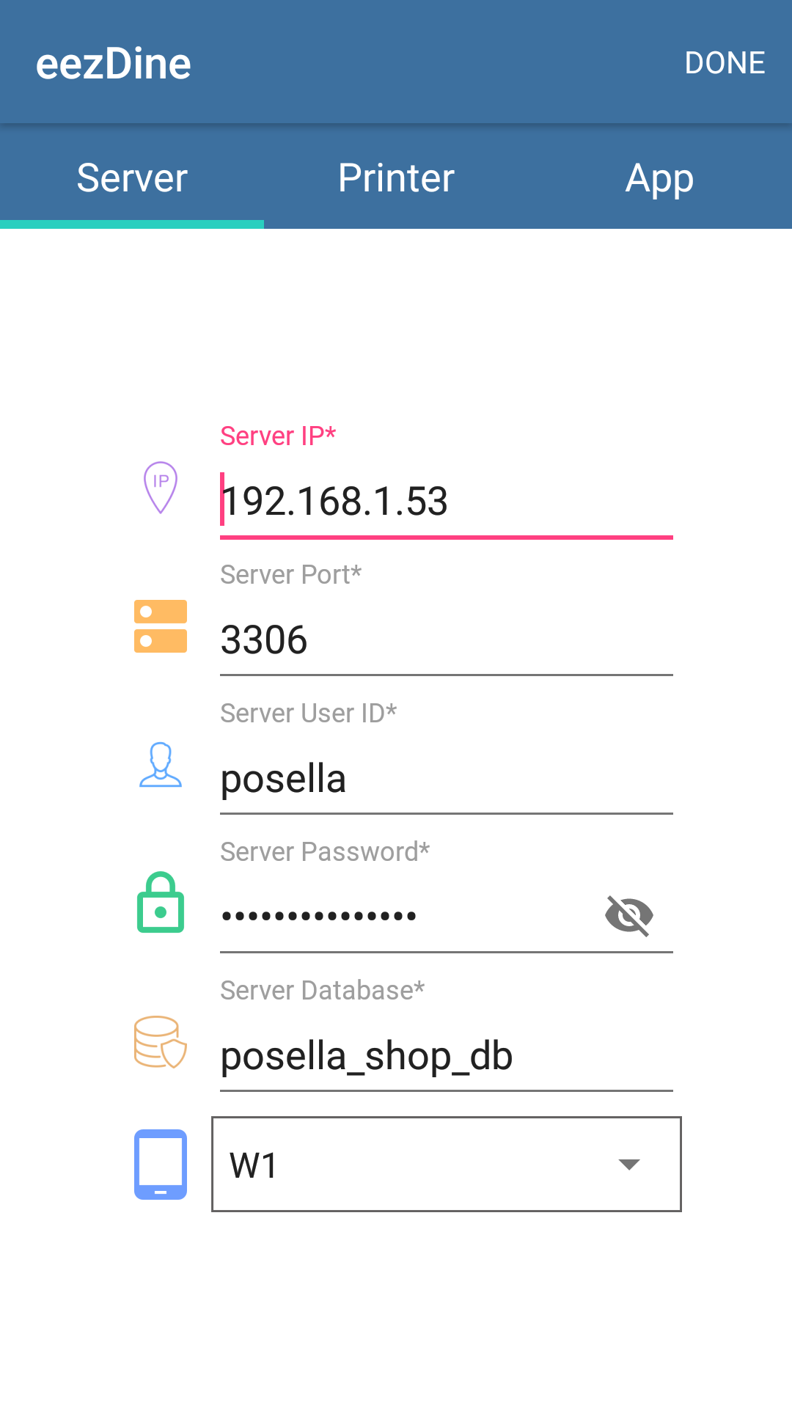
Fig:Window for server settings.

When you see a window shown in the figure,you have to enter the server ip,server port,server user id,server password,server database and select the location from the list.

Field | Description
Server IP | IP address required to connect to the server.
Server port | Port number required to connect to the particular database or server.
Server user id | Id which must be entered by the user to connect to the server or to start the application.Enter the id already registered.
Server password | Password must be entered by the user to connect to the server.
Server database | Enter the Database name,which is used to connect to the server.
Location | Select the location from the list.Location is the list of available devices connected to the server.

2.2 Printer Settings

After configuring the server settings,move on to the printer settings .When clicked on the Printer button , a new window will open as shown below. Choose BOT or KOT printer.Also enter the IP address of the printer which used to print the order details and the port number.Also there are fields like print all items,Enable condensed printing,enable beep sound ,reset button and it should be entered as per the needs.
In this window there is option for test print,this works only when the configuration in the server side is complete.We can also make changes in the receipt using receipt settings,there is options like use alternative name and show seat in kitchen print.

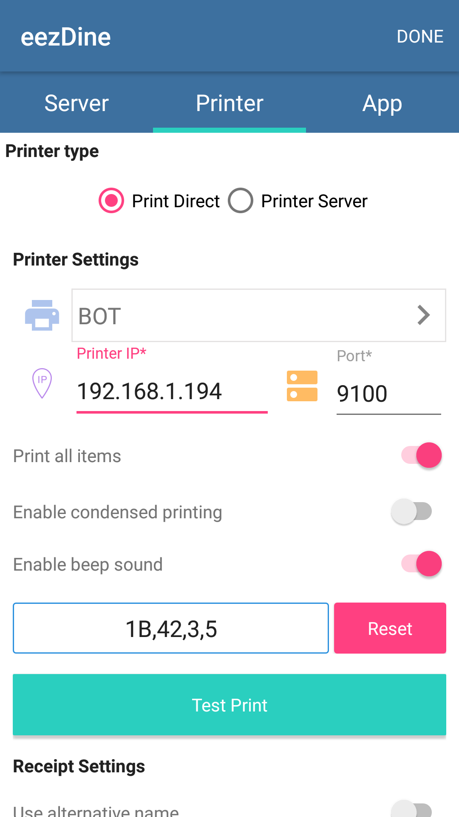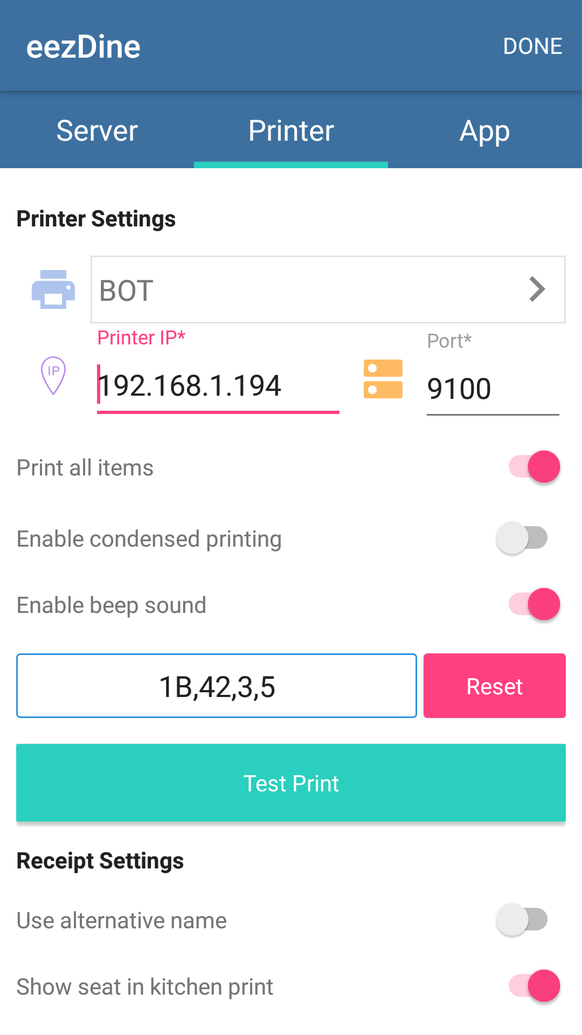

Fig:Printer settings window.

Field | Description
Printer IP | IP address required to connect to the printer.
Port | Port number of the printer.
Print all items. | When selecting BOT or KOT,if selected items contains both KOT and BOT , if we enable print all items both BOT and KOT items shall be included in the receipt.
Enable condensed printing. | If this field is enabled,it supports old print system receipt format.
Enable beep sound. | If this feature is enabled,the printer shall produce a beep sound when printing.
Reset | If the reset button is clicked ,it will adjust the beep sound settings.
Test print. | If this button is clicked, a test print is generated.
Use alternative name. | If this field is enabled ,alternative names can be assigned to items.
Show seat in kitchen print. | If this feature is enabled,seat count can be included in the receipt.

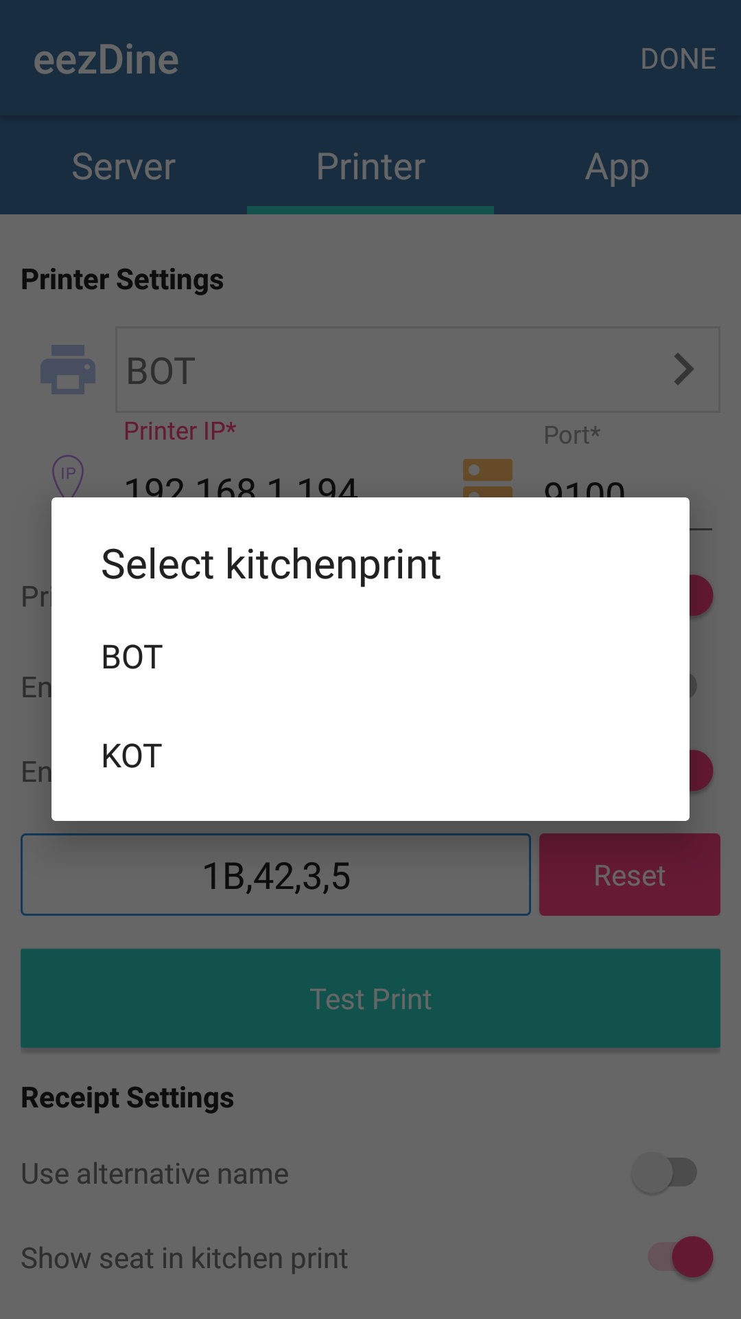
Fig:Select print.

The above figure shows how to select the printer. There are two types of prints ,ie,BOT or KOT.

When printer type is changed to Printer Server ,a new window will open as shown below.In this window there is options for configuring printer settings.Printer settings have fields like printer ip and port which must be filled out.Also there is option for test print and when clicked on the test print button ,a sample print is generated.

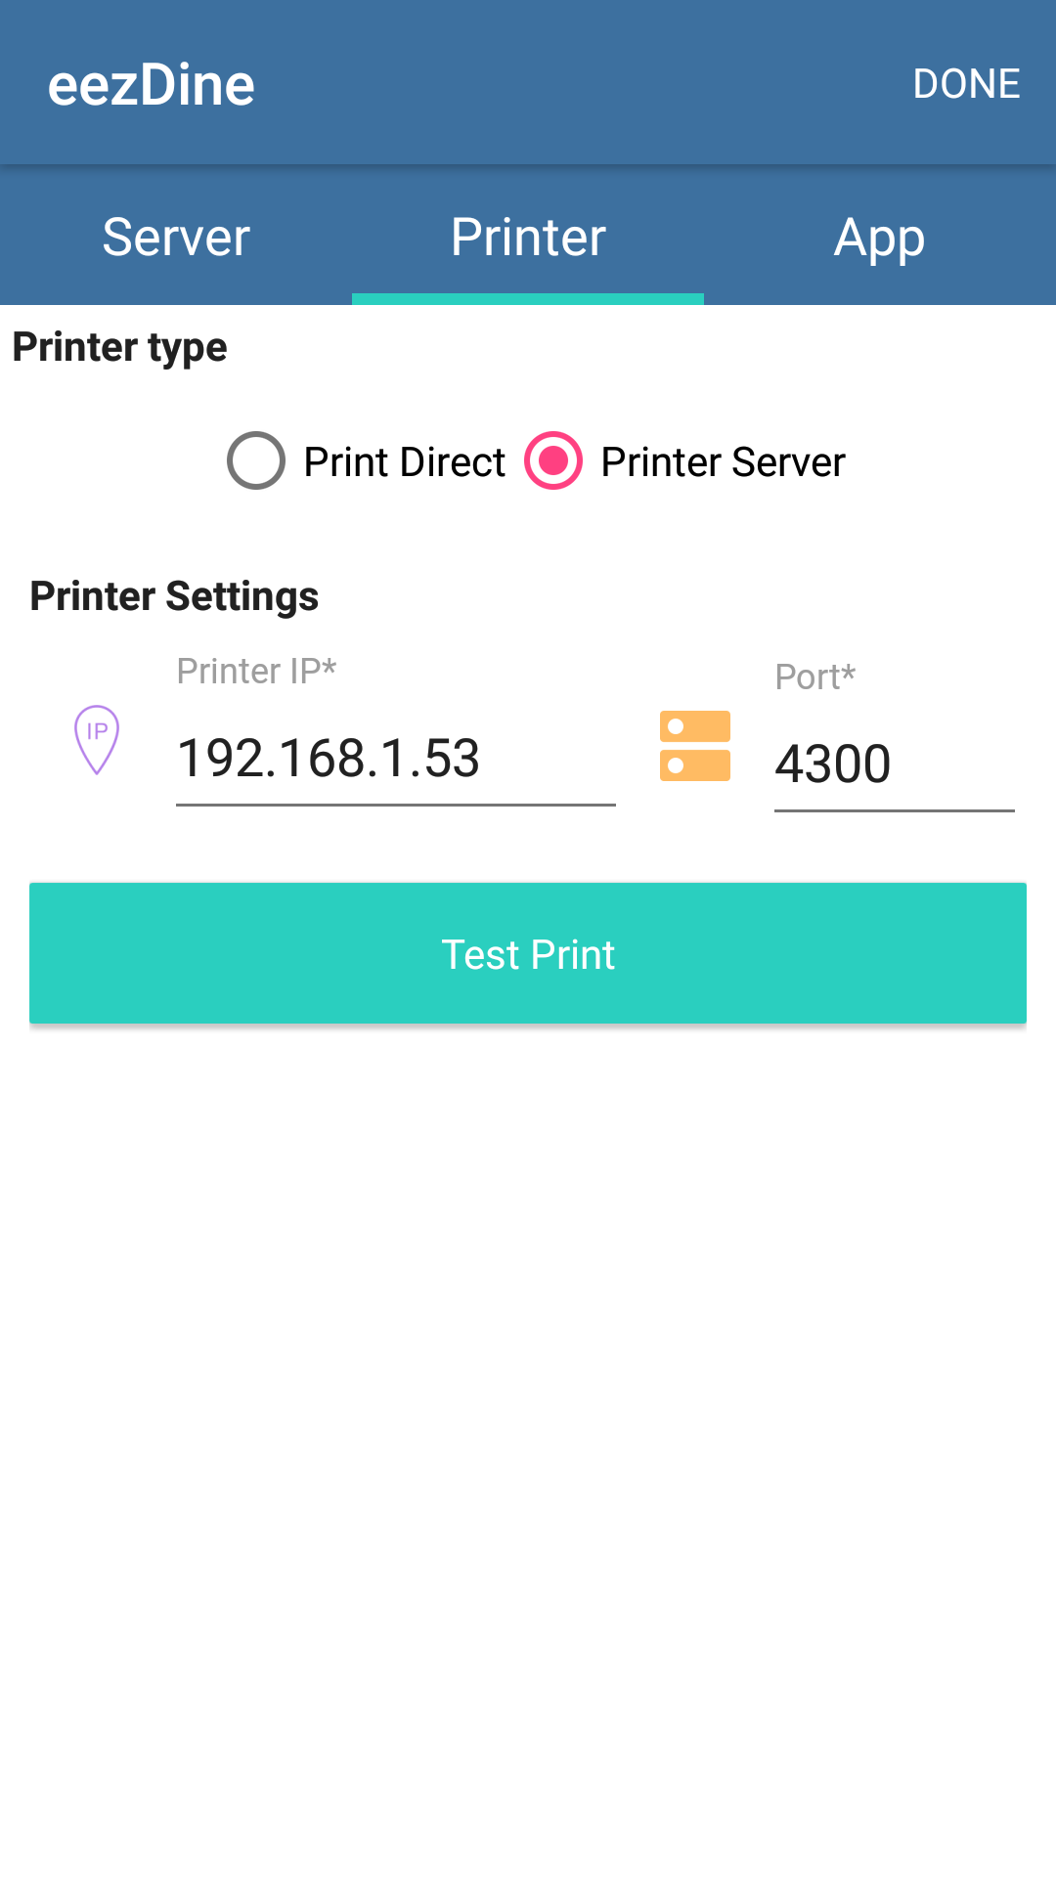

Fig:Printer server settings

Printer IP is nothing but the IP address of the printer and port number belongs to the port of the printer which which we are connecting.

2.3 UI Settings

After completing server and printer settings there is option for adjusting the ui settings.When clicked on the App , a new window will open as shown below.

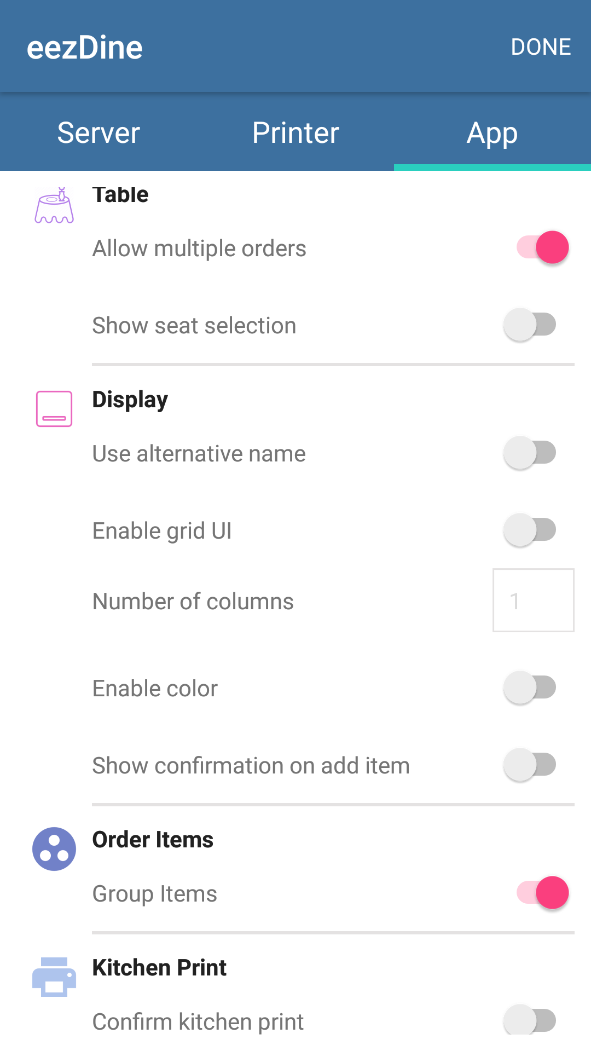

Fig: UI settings.

In this window there is fields for configuring the settings of table arrangement,display settings,for order items and for kitchen print.Enable the fields or subfields as per the requirement.

Fields | Description
- Table. | Table settings.
1.1)Allow multiple orders. | If this feature is enabled multiple orders can be allowed for same table.
1.2)Show seat selection. | This feature is for showing seat selection.
2)Display. | Display settings.
2.1)Use alternative name. | This feature allows to give alternative names for items with lengthy names or for all items.
2.2)Enable grid ui. | This feature is for enabling grid ui in the display.
2.3)Number of columns. | This feature is for setting the number of columns in the display.
2.4)Enable color. | This feature allows to set colors in the display side.
2.5)Show confirmation on add item. | When adding a new item to the already taken order,this feature helps to show a popup for confirmation on the ordering of new item.
3)Order items. | Order items settings.
3.1)Group items. | If this feature is enable,it helps to group items for different orders in a table.
4)Kitchen print. | Kitchen print settings.
4.1)Confirm kitchen print. | This feature is to confirm kitchen print.

3.Waiter List

After completing all the configurations and when “done” clicked , a new window will open as shown below.This window shows a list which contain the waiters available to take orders.

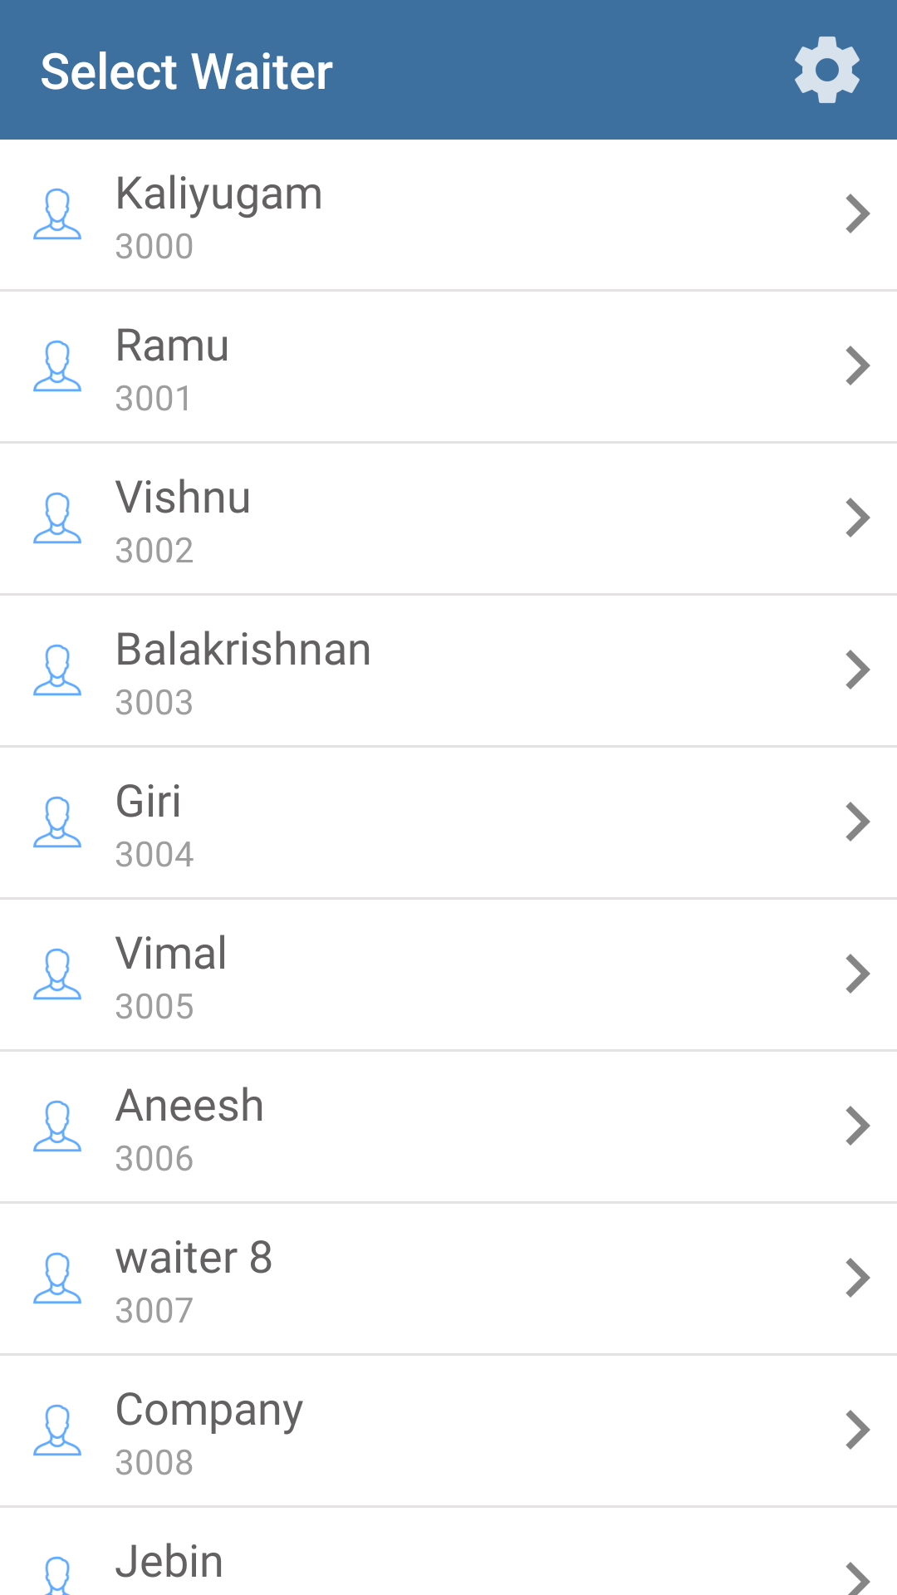

Fig:Waiter list.

The above figure shows the waiter list and each waiter added in the list can login to their account and can take orders.

4.Login

After selecting the waiter from the waiter list,a new window will open for login as shown below.

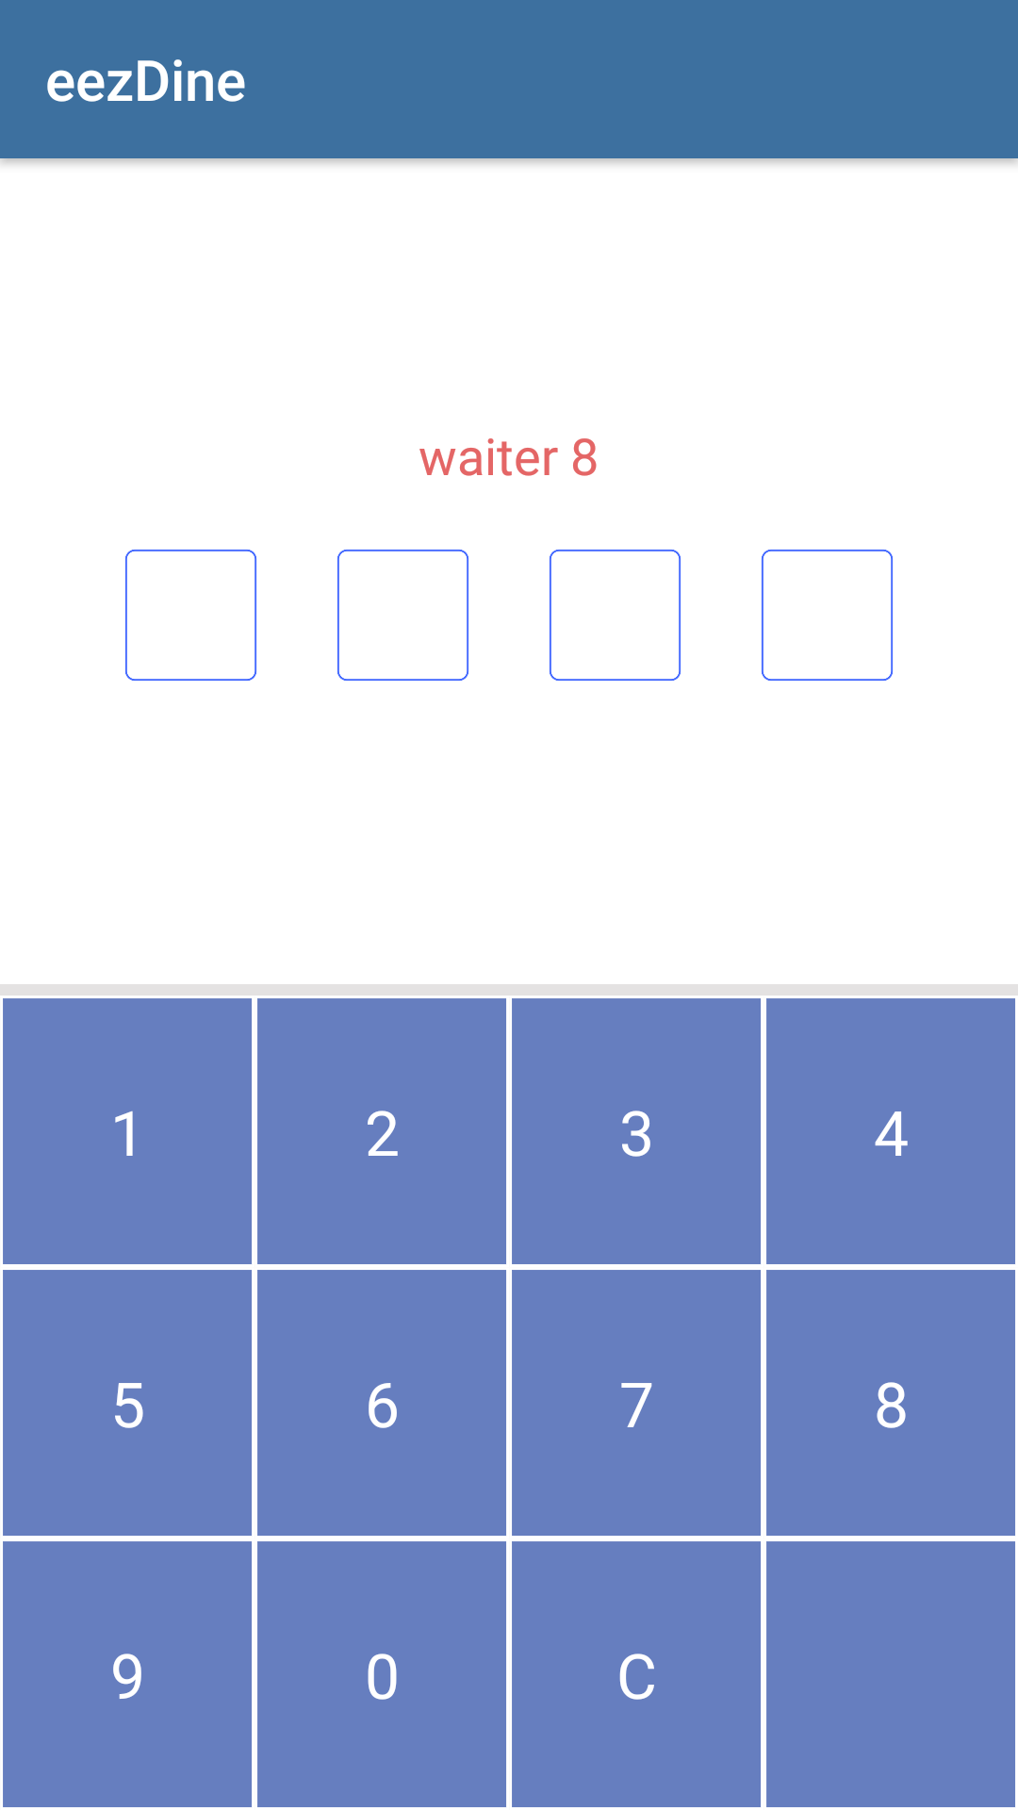

Fig: Waiter login window.

By entering the password ,a waiter can enter to the next page for taking orders.

5.Table List UI.

5.1 Location Selection.

In this app there are three locations allotted for seating,ie,Restaurant-sitting,Bar-sitting and Pier side-sitting.Waiter can select the location according to the customer’s seating.The window will be as shown below.

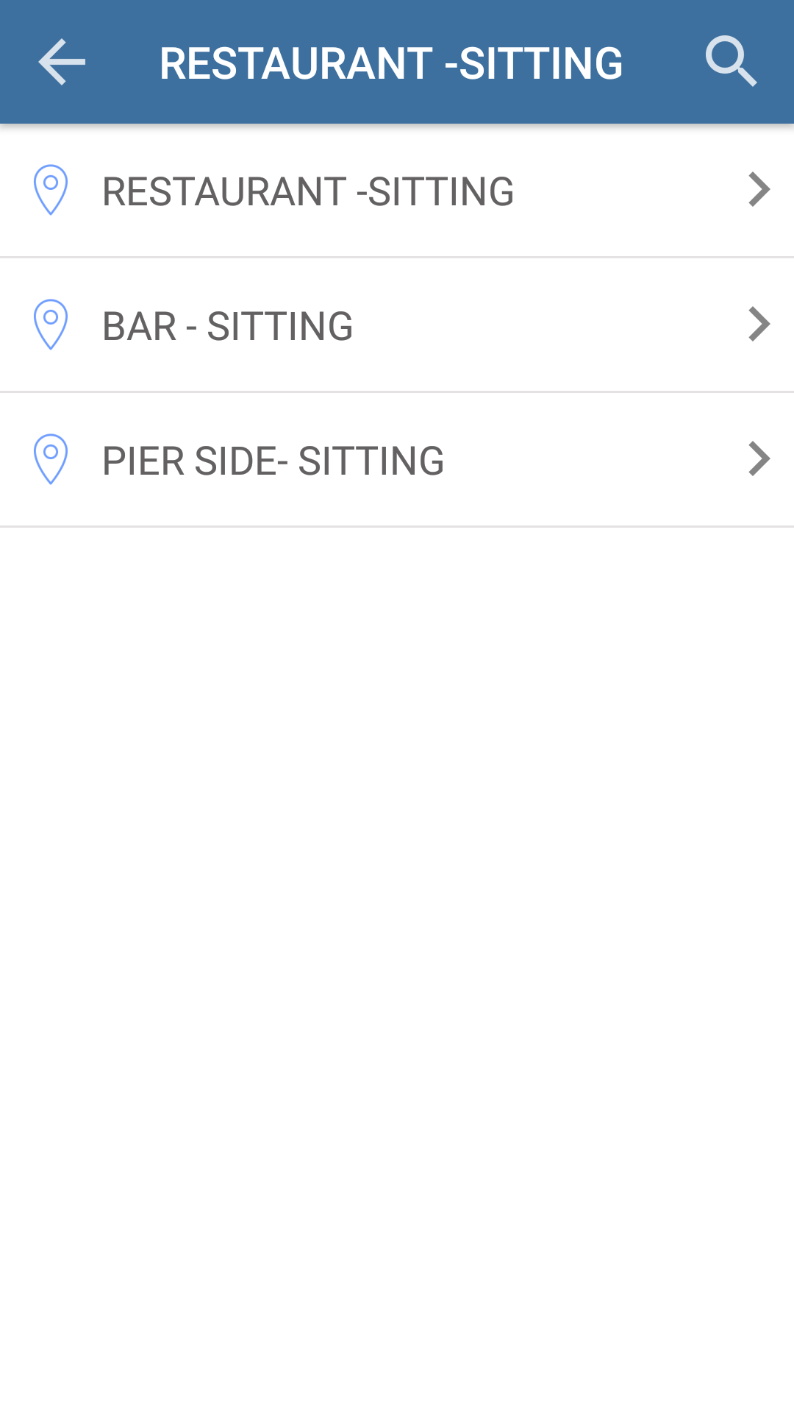
Fig:Location selection.

5.2 Table List

Table list according to different locations are shown below.

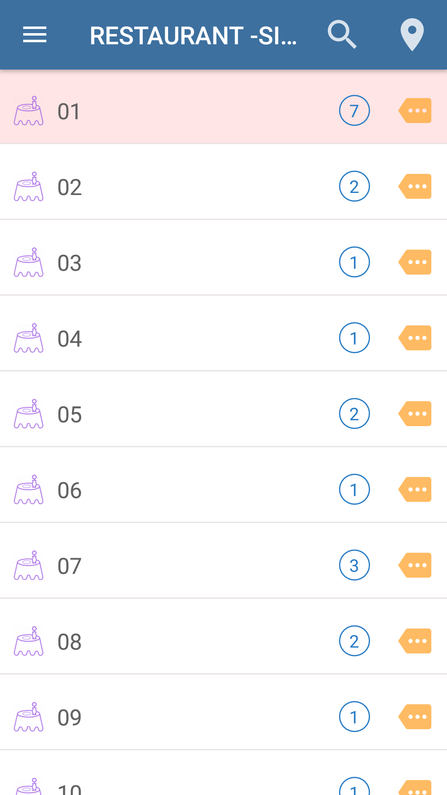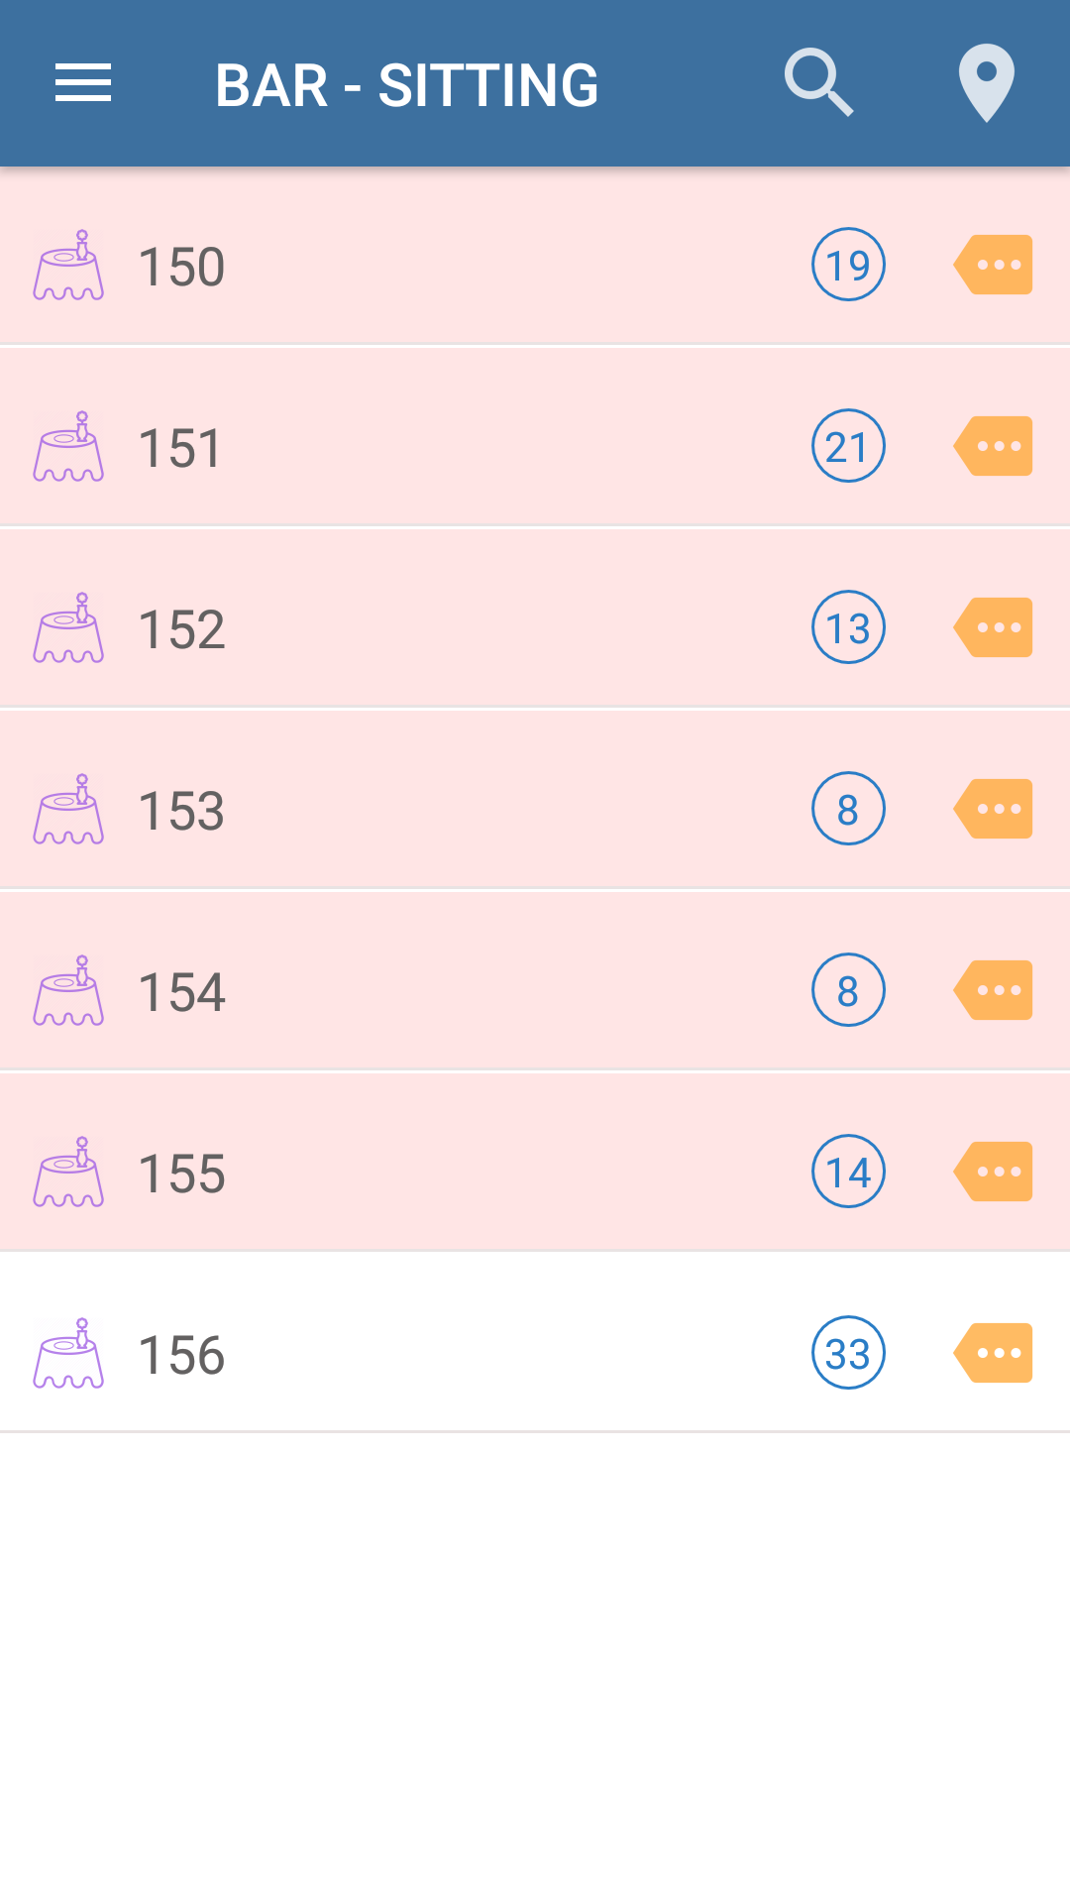

Fig:Restaurant side sitting table list Fig:Bar side sitting table list.

The above figures shows the table lists of Restaurant sitting and Bar side sitting.

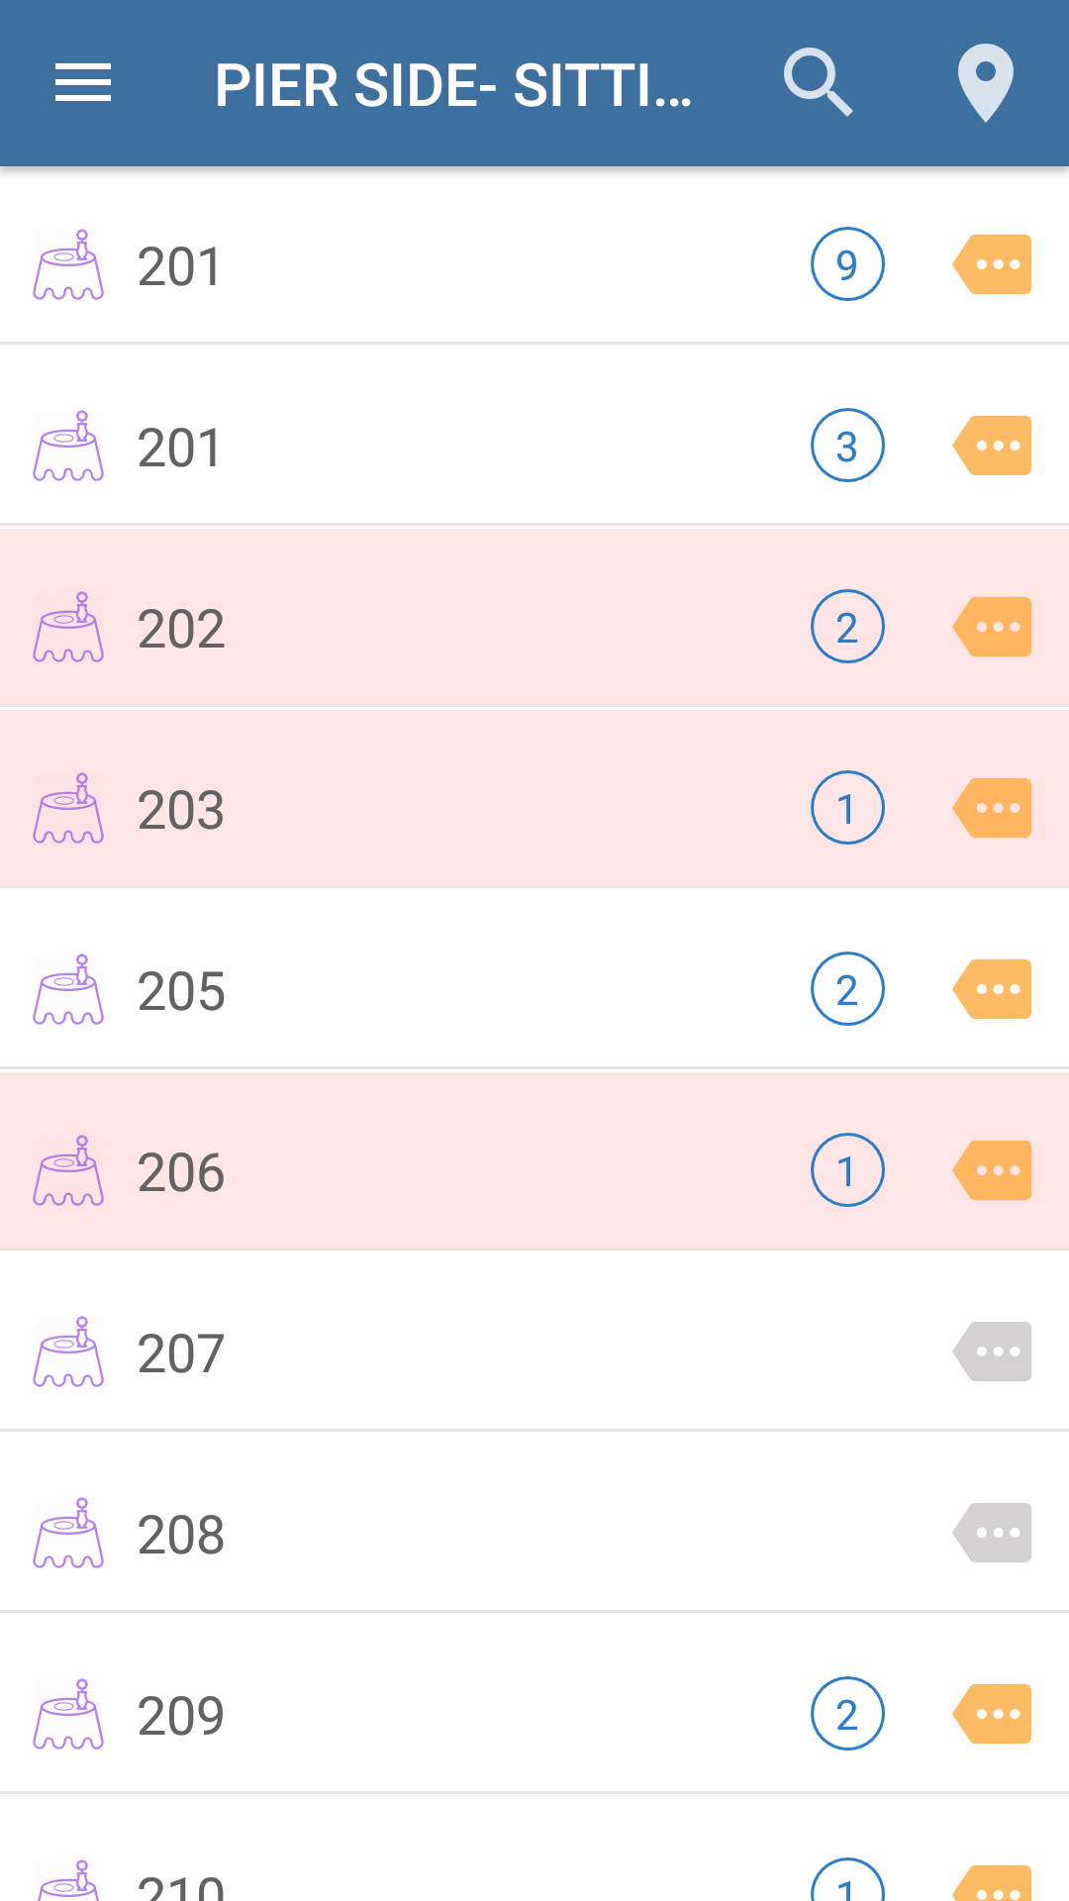

Fig:Pier side sitting table list.

The above figure shows the table list in Pier side sitting.

5.3)Seat and Pax Selection

Select a table from any of the three locations , and when selecting a particular table a window will open as shown below.

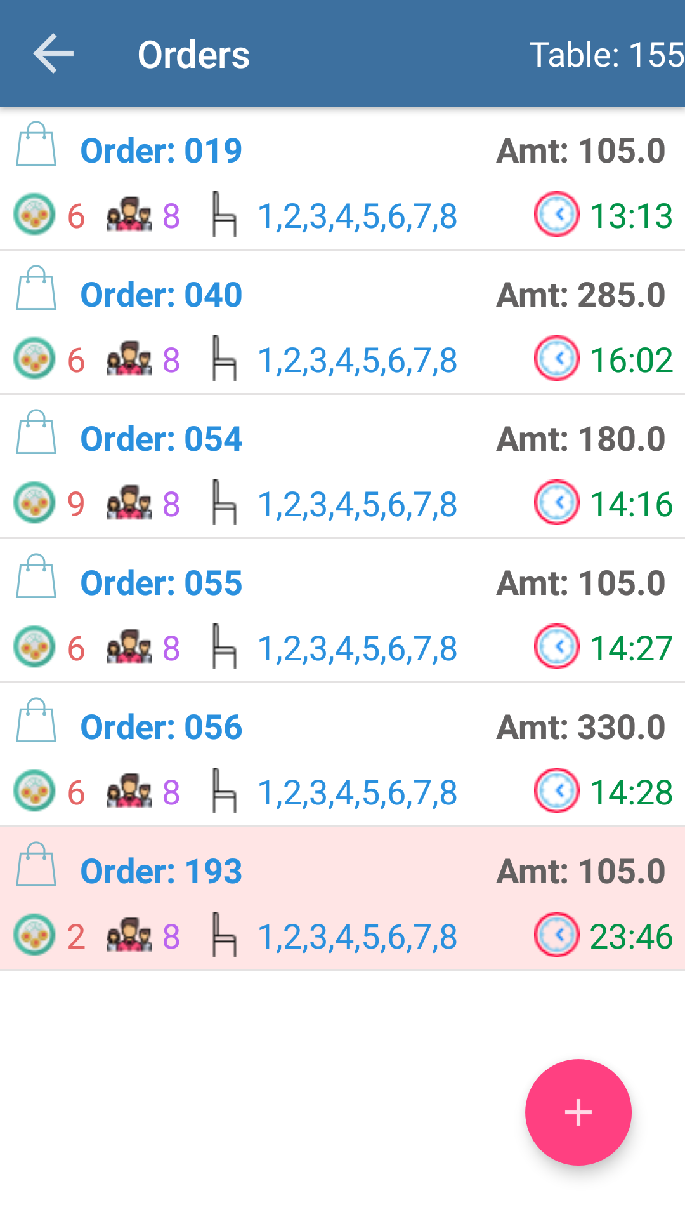

Fig:Table list. Fig:Order list in the table.

In the order list window there is red button for adding orders.In the ui settings, if we enable “ show seat selection”,and after clicking the button in the order list we will be able to see a new window for “seat and pax selection” as shown below.

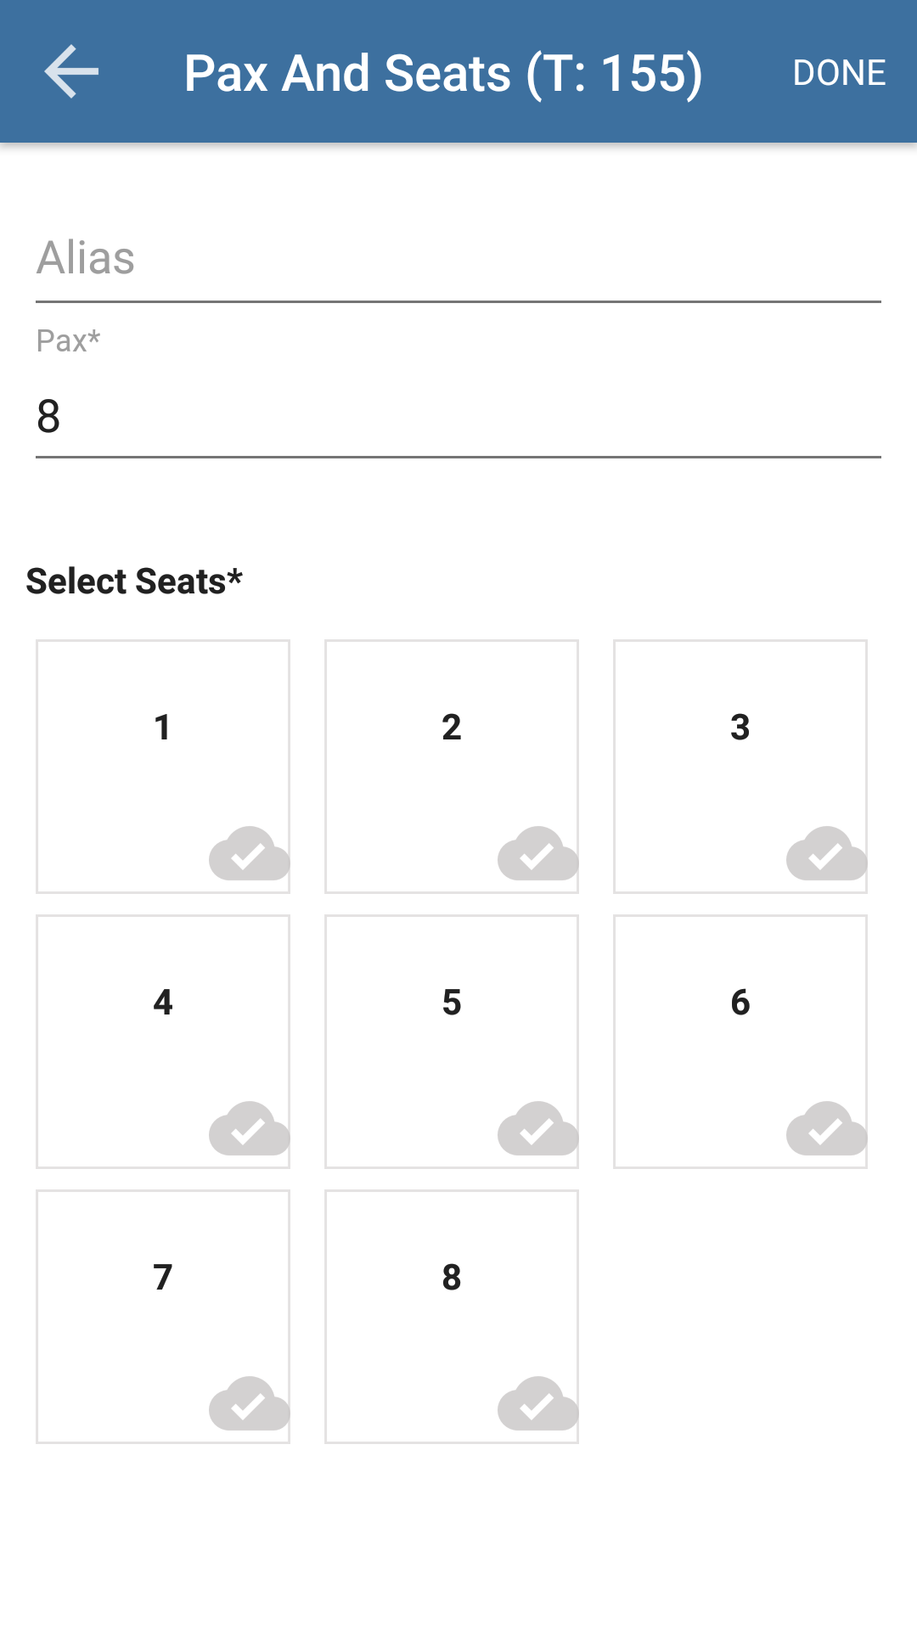

Fig:Seat and Pax selection.

By selecting the seats ,the waiter can take orders accordingly.

6.Order List UI.

6.1 Order List.

When we select a table from any of the three locations ,a new window will open as shown below, and there may be list of orders if orders were taken already and there will be a button for adding new orders.

Fig: Order List.

When clicked on the button ,new orders can be taken.

6.2 Order Menu Options.

When clicked on a particular order in the order list , a new window will open as shown below.

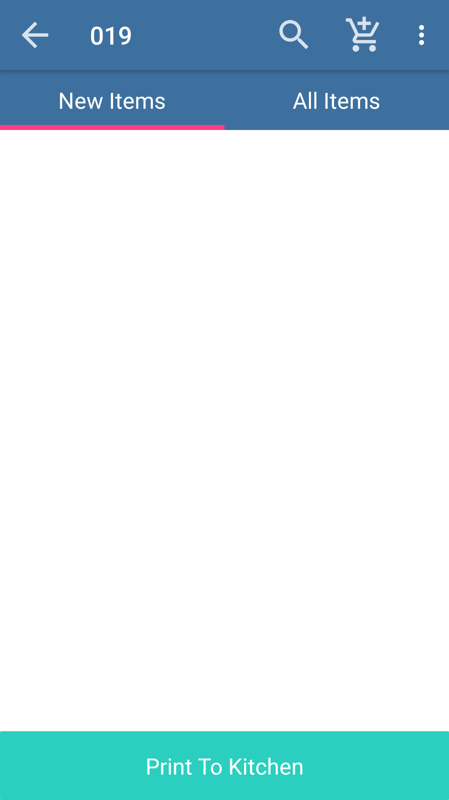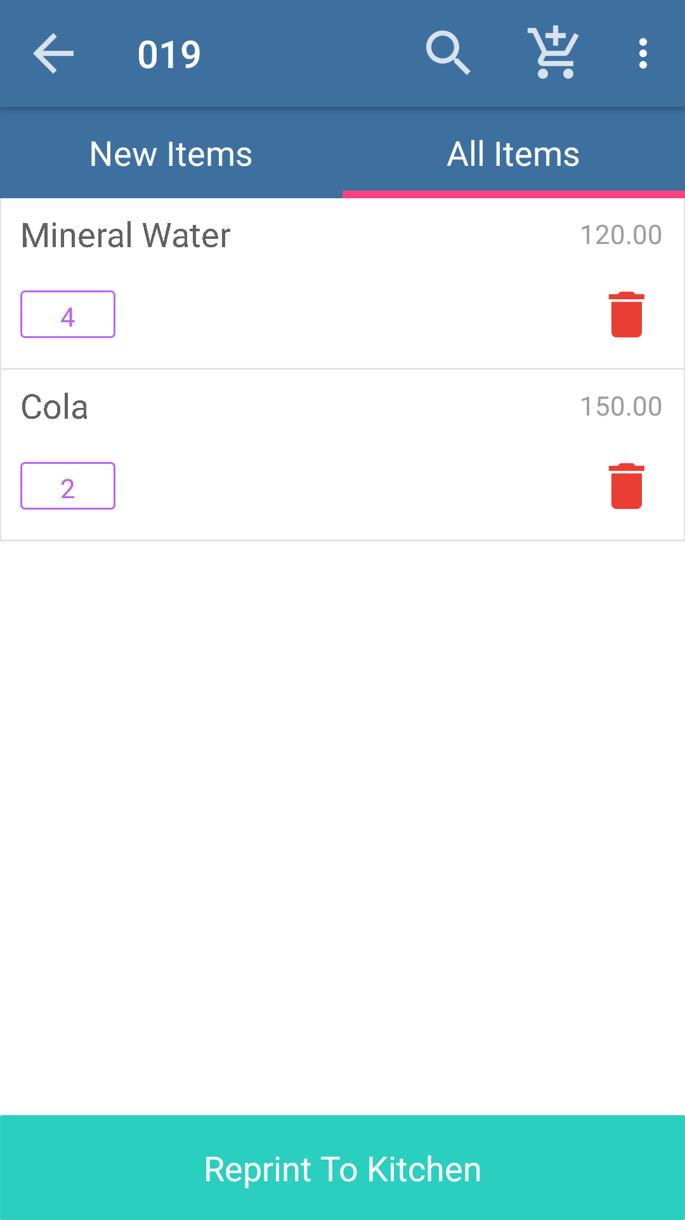

Fig: New Items Fig: All Items

This window have two options for showing the “new items” and for showing “all items”.In this window there are several options like search button for searching items from ordered items and there is option for adding items from cart and there is options for deleting the order completely and also there is option for seat and pax selection (only if we enable “show seat selection” in ui settings).

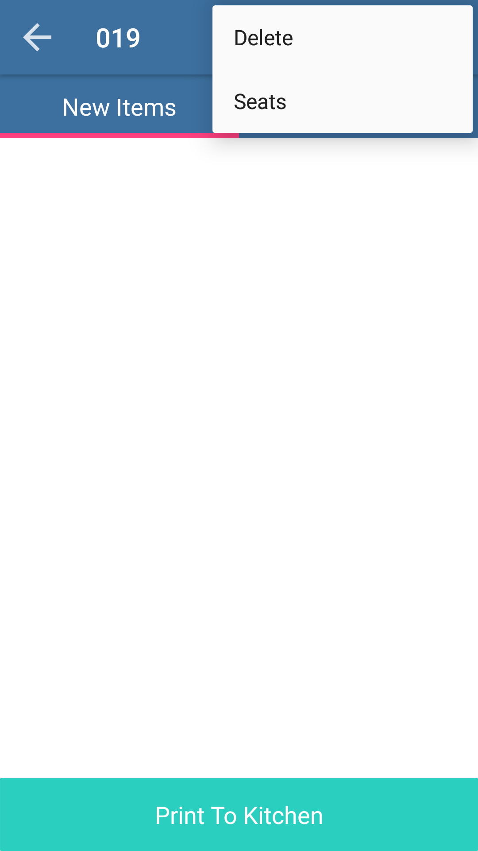

Fig:For deletion of order.

Also in this window,after selecting the items ,there is button for “print to kitchen”.

7. Item List UI.

7.1 Item List.

In this window we can see the items available and there are options for searching an item ,adding an item to cart and option for setting ‘pax and seats’ and menu for selecting the location.

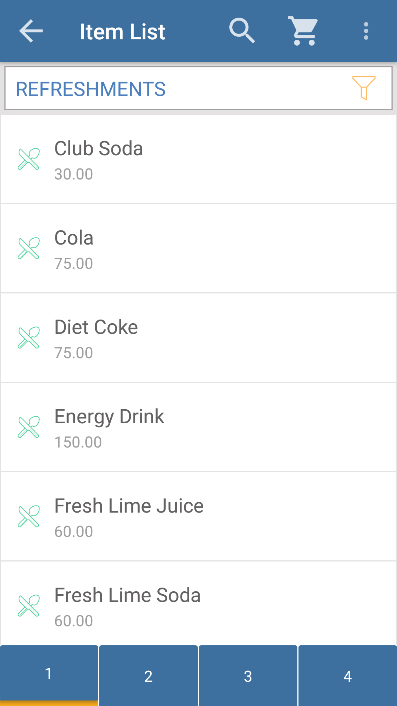

Fig: Item List.

The above figure shows the item list and the available options in the window.In this window there is option for searching an item,for adding the item to cart and option for setting pax and seats and menu for location selection.

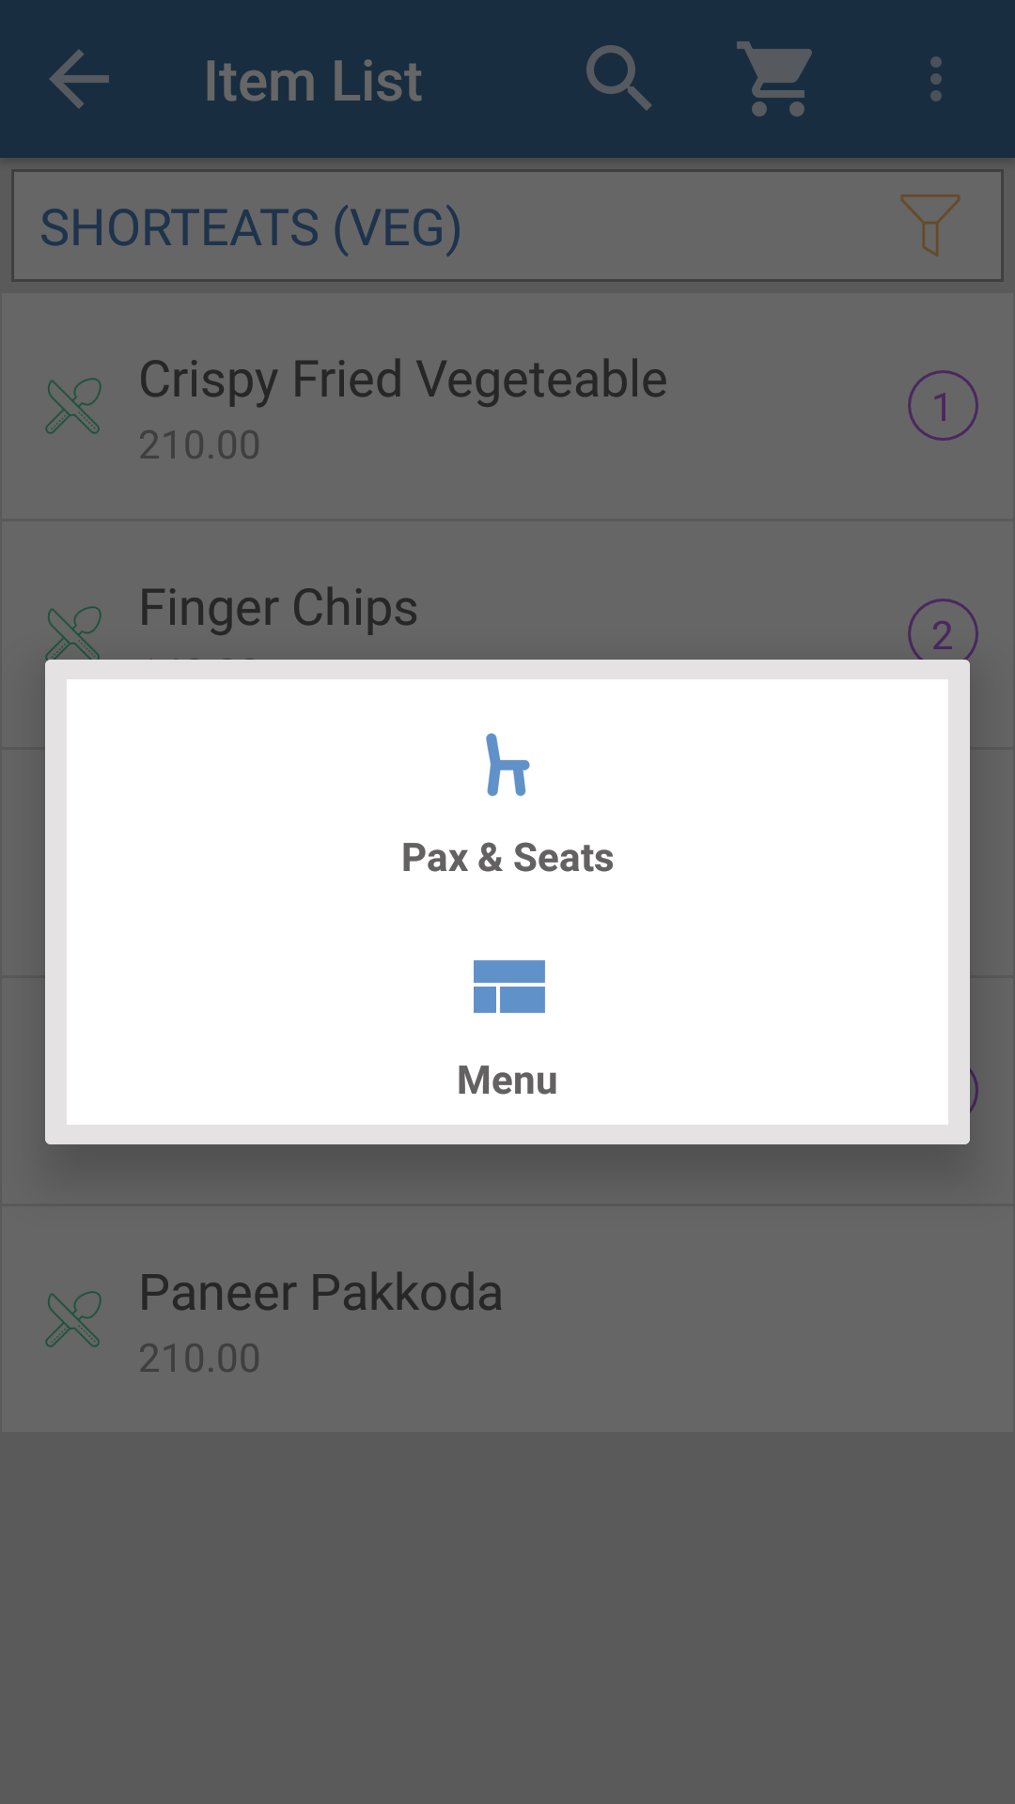

Fig:Pax and seat selection ,Menu selection.

When clicked on the three dotted side bar ,we can see a window as shown above.It includes options for setting up the seat and pax and for location selection.

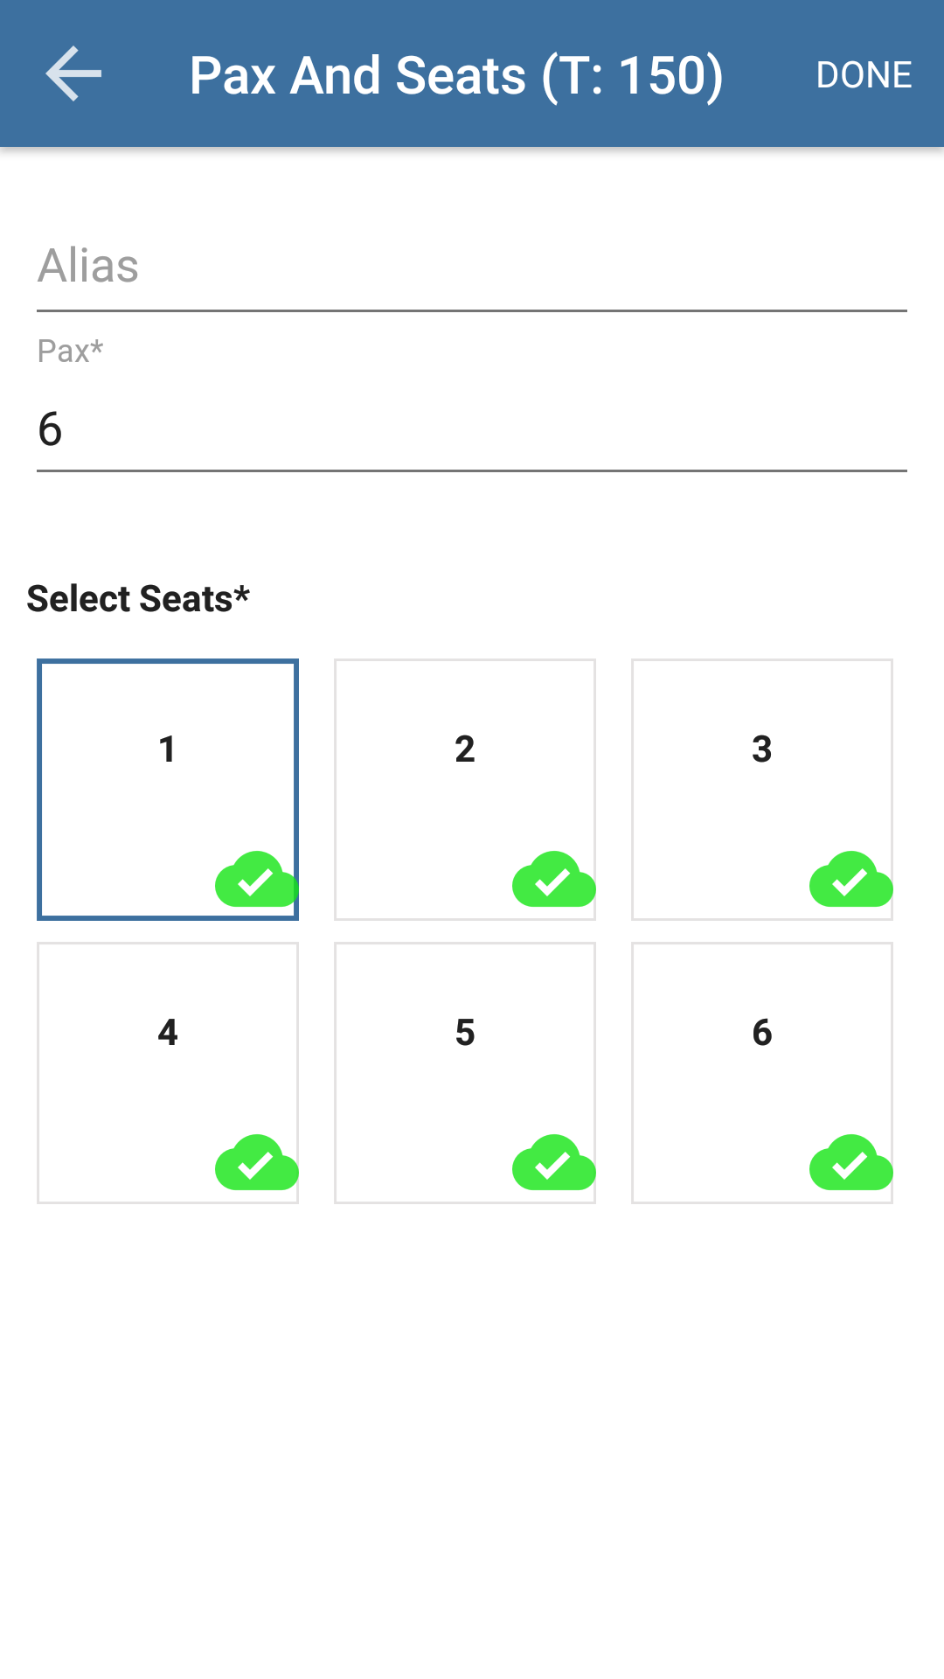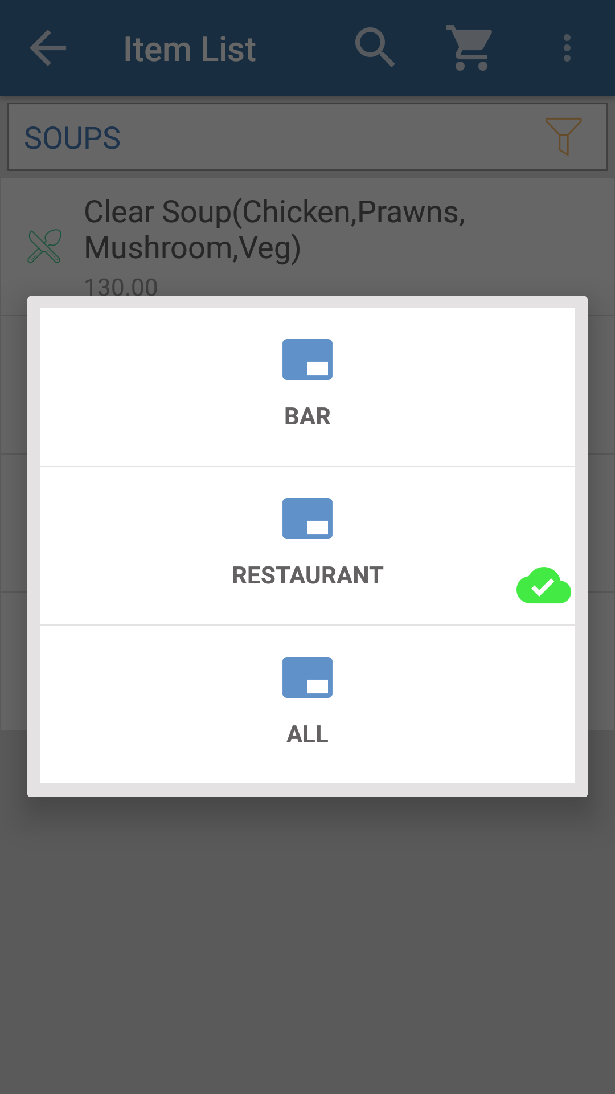

Fig:Tax and Pax Selection. Fig: Location Selection.

The above windows show how to set pax and tax and also the location selection.

7.2 Menu Selection.

In the item list window when we select different items and their quantity ,the window will look like as shown below.

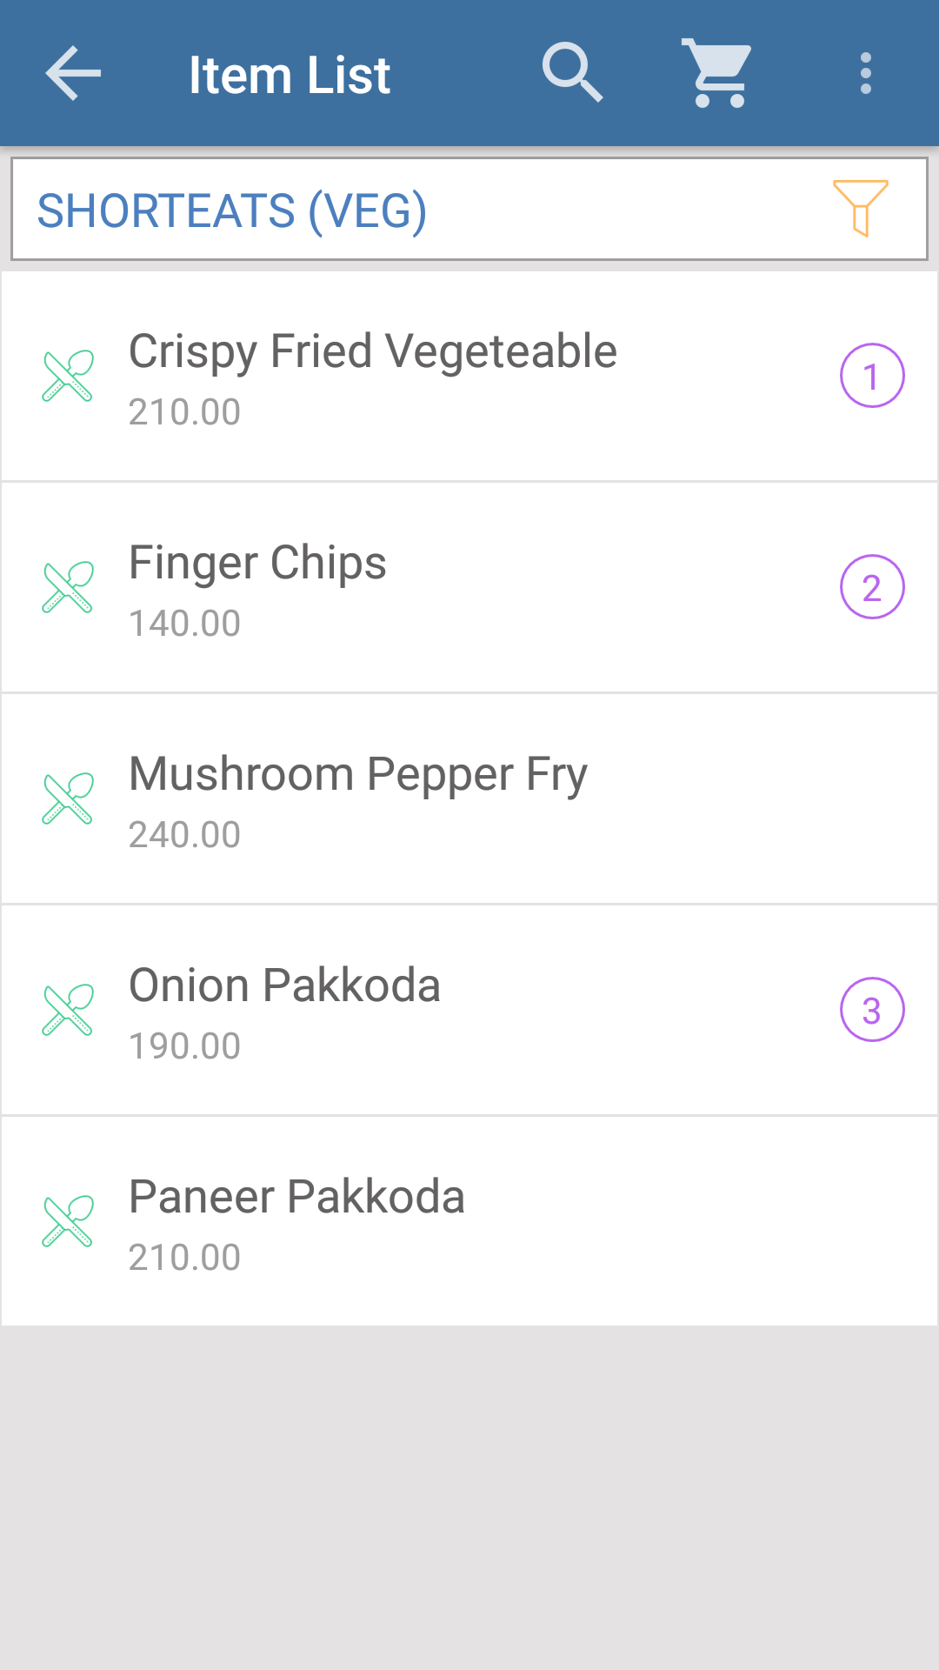

Fig: Menu Selection.

The window will look like as shown above when different items are selected.

7.3 Item Class Selection.

In the item list window there is option for changing the item class and there are different item classes for selecting different items.the window will look like as shown below.

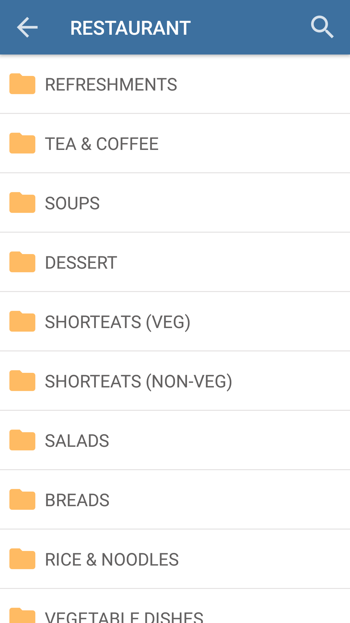

Fig: Item Class Selection.

There are different item classes as shown in the above window.All the item classes contain different items.

When we select a particular item class, a new window will open as shown below and the window contain the items under the selected item class.

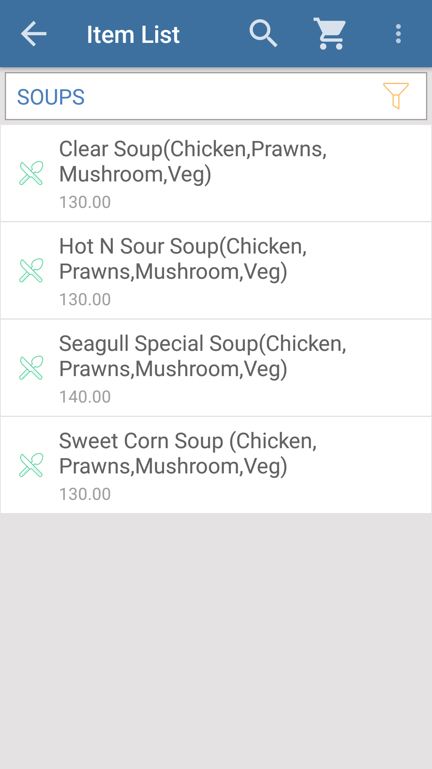
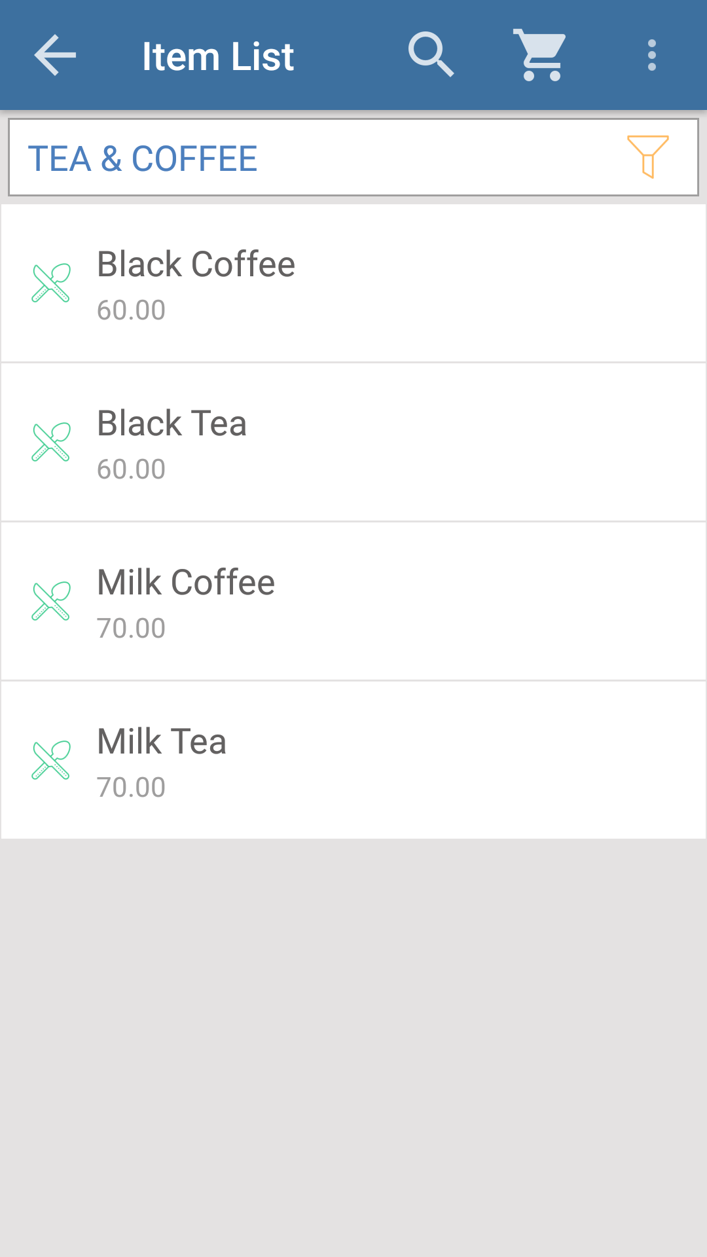

Fig: Item Class - Tea and Coffee. Fig: Item Class - Soups.

The above windows show the items under item classes ‘Tea and Coffee’ and ‘Soups’.There are different item classes and different items under each of the item classes.

8.Cart UI.

8.1 Cart Item List.

For a particular order when we select items from same or different item classes and added to the cart ,the cart will look like the window shown below.

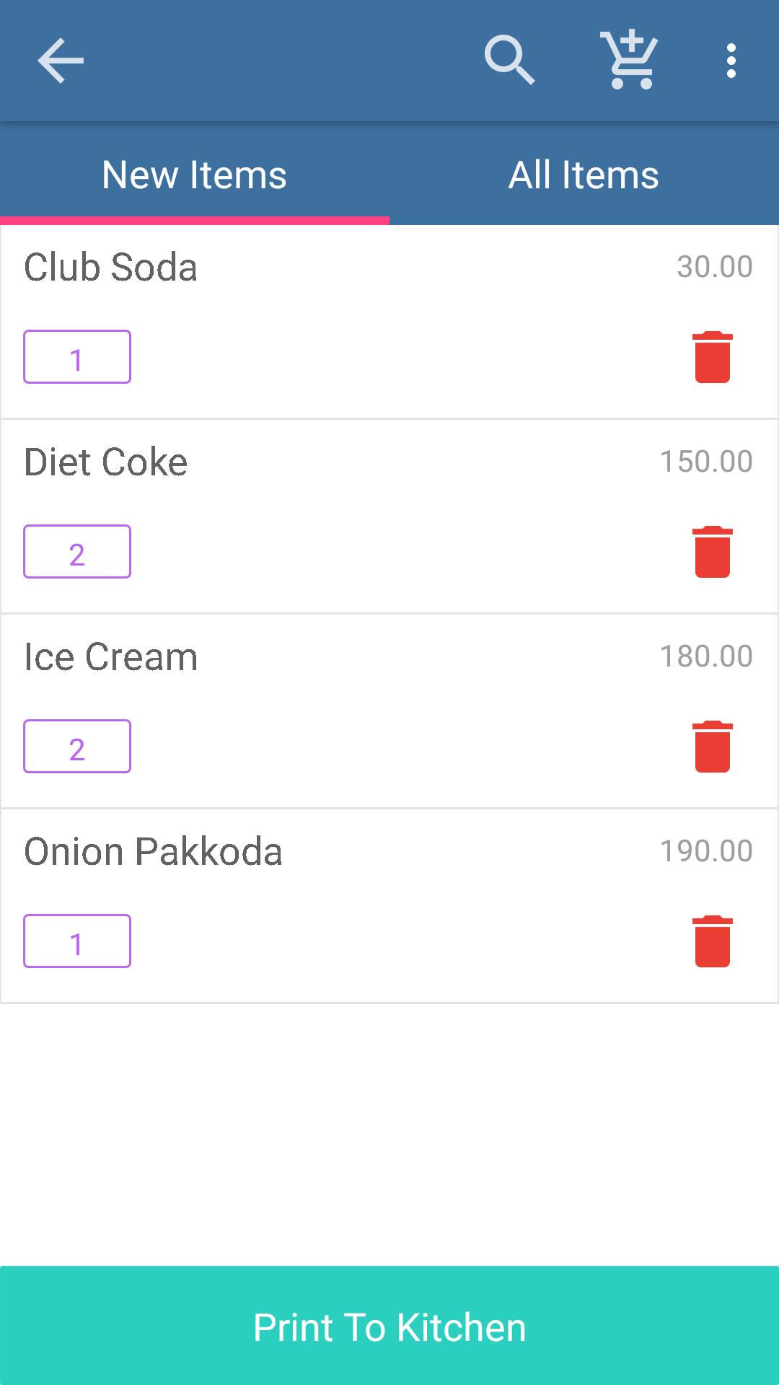

Fig:Cart Item List.

In the above window ,the item list contains items from different item classes and there is option for searching an item,for viewing the newly added items and for viewing all of the items and there is option for deleting the order and also to select the number of seats. When clicked on the side bar of three dots ,a new window will open as shown below.

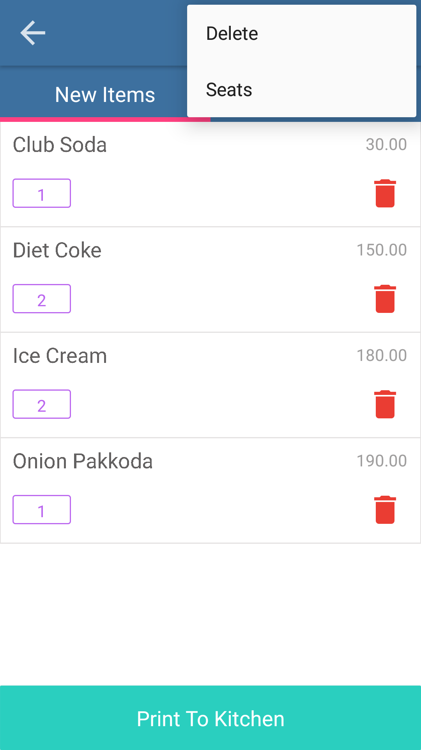

Fig: Deletion of order and seat selection.

When clicked on the delete a new box will open as shown below.

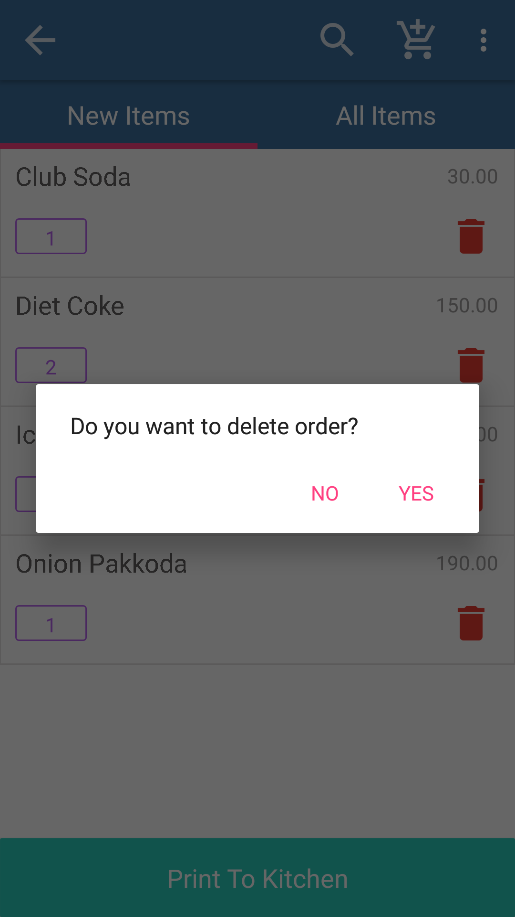

Fig: Deletion of an order.

The above window shows how to delete a particular order.When clicked on the seats ,we can select the number of seats.

8.2 Item Edit.

In the cart ui ,when clicked on a particular item a new window will open as shown below and that window contains option to edit the quantity of item and for adding any remarks.

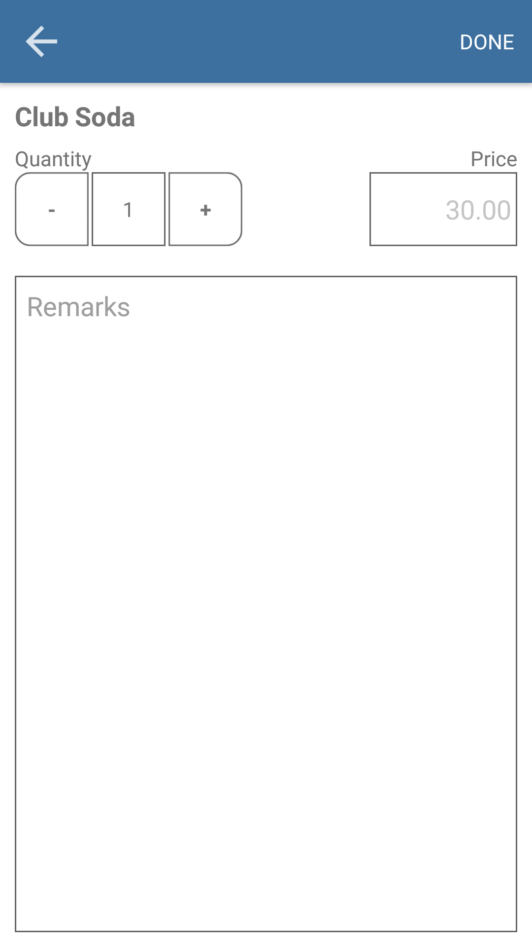

Fig: Item edit.

In this window we can change the quantity of the item and also we can add remarks.There is option for viewing the price when an item is edited and after editing click on the done button to save the changes.

If the need is only to change the quantity,just click on the number of quantity shown under each of the items selected then a box will pop up as shown below.

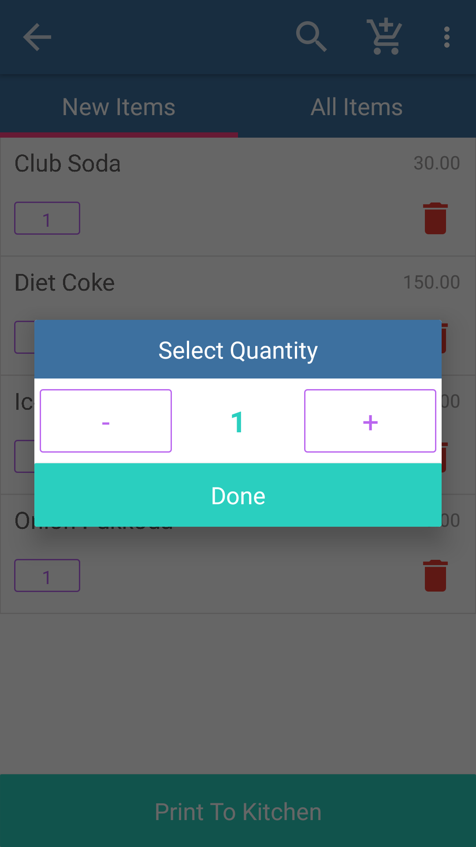

Fig:Item Edit.

8.3 Parking and Printing.

After adding the items as per the order to the cart ,in the cart there is option for print to kitchen.The window will be as shown below.When print to kitchen is clicked two new buttons will appear ,ie, ‘Cancel’ button and ‘Confirm’ button.When clicked on the cancel button,print to kitchen is cancelled and when clicked on the confirm button bill is generated by the printer.

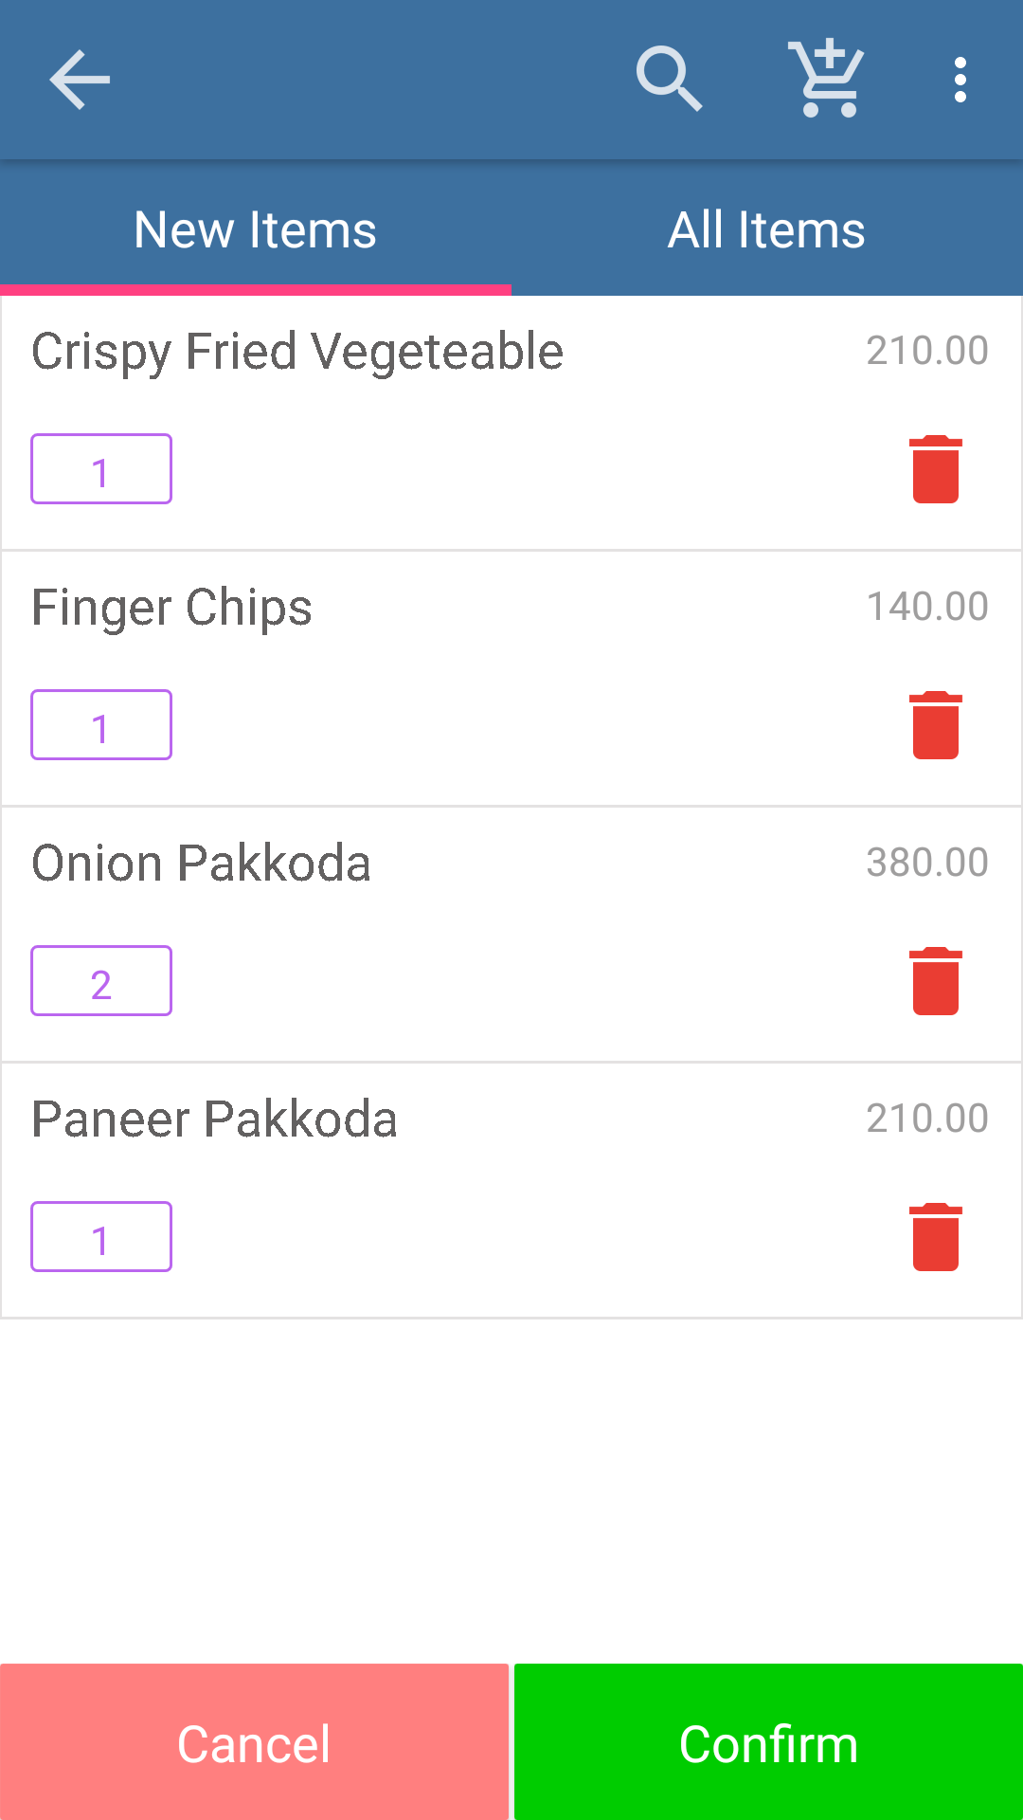

Fig: Print To Kitchen. Fig:Cancel and Confirmation buttons.

The above two windows are the final screens to generate bill and also for cancelling and confirming the ‘print to kitchen’.

